# Drive Motors

The drive system will consist of 2 drive motors at the back and a castor ball at the front. This architecture is similar to other high speed line following robots.

The motors to be used are “210:1 Micro Metal Gearmotor HP 6V with Extended Motor Shaft” from Polulu.

No load speed: 150 rpm (100 mA)

Stall torque: 3.0 kg*cm (1.6 mA)

Due to power constraints we need to be careful not to stall the motors at any time during testing. During normal operation this should not be a concern, but human error whilst testing may cause a stall.

# Drive Motor Drivers

Currently considering a couple options due to cost reasons.

Here are the following options:

* Dual MAX14870 Motor Driver Shield for Arduino
* L298N DC motor module
* DRV8833 Dual Motor Driver Carrier
* DRV8835 Dual Motor Driver Carrier

All of these options are great choices depending on a wide variety of considerations such as cost, features and ease of use. It should be looked into in further detail later on.

# Battery Pack

Plan to use NiMH cell chemistry as it is a stable chemistry which is quite power dense and cheap. Does not significantly suffer from memory effect and is quite robust to charge compared to lithium types. Also, more environmentally friendly to dispose of compared to others.

Cell nominal voltage: 1.2V

Cell fully charged resting voltage: 1.4V

Cell fully charged voltage connected to charger 1.6V – this is the voltage when the cell is fully charged at the charger. You may see this on the internet, but it is not relevant when discharging.

6S1P NiMH Battery

Battery nominal voltage 7.2V

Battery fully charged resting voltage: 8.4V

Reason for choosing 6S1P config is that the Nucleos onboard 7V-12V regulator can handle this input. This is also high enough for the 6V, N20 gear motors planned to be used.

to regulate down to 6V required for the motors chosen which are N20 type gear motors. Each motor will likely require its own separate and isolated regulator for the current draw of each motor. 3A regulators.

# Wheels

Buy or make wheels. Considering making press fit Delrin wheels with a cast rubber wheel for fun and more flexibility. Will also help save costs potentially.

One option that can be bought is from Jsumo. Polulu also sells wheels called Solarbotics RW2 Wheel. They ALSO sell casters which may be useful for the front.

A lot of good wheels for this type of application are known as “Sumo” wheels. The are very wide and flat. The materials consist of a metal or hard plastic core, with an over molded silicone tire.

If you make silicone cast wheels, be sure to take time to make a good mold. USE RELEASE AGENT. The person I saw do it online with 20A – 30A shore hardness polyurethane and it seemed pretty good for him.

Note that making wheels DIY will take up considerable amount of time that could better be spent elsewhere on the bot

# Sensors

## Localization

Lidar: Yahboom Lidar EAI YDLIDAR X3 5Hz~10Hz Adjustable 8m Radius Ranging Scanning for Obstacle Avoidance and Navigation of Robots Support ROS1&ROS2

## Color detection

Lots of I2C devices but could be tricky to solder up. Also will have complications due to multiple devices with same slave address.

There are some good photo diodes to choose from, but there are not enough analog inputs to sustain an array of sensors. There are a couple options to get around this though.

* Use a hardware trigger to digitize the signal for a given threshold which can be tuned. Then wire all of the digital signals into the nucleo.
* Use a multiplexer of sorts.
* Use a smaller array
* Use hardware logic to simplify the output
* Just used bounce bounce sensor logic
* Use this guy: <https://rocelec.widen.net/view/pdf/ykgocwgvry/MAXMS08280-1.pdf?t.download=true&u=5oefqw>

With this you get 8 analog inputs, 1 byte digital output, 3 bits for register select. 20 uS max response time. This could get very complicated though. It needs -10V for ADC.

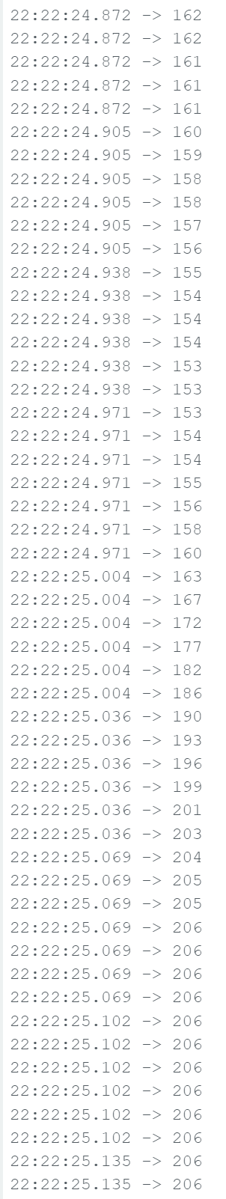

Data from simple test using LDR and blue LED

Swing from analog input when sweeping from red to white sign 206 to 160.

More pictures on phone

More testing needed to further evaluate idea.

# Photo Resistor and Blue LED idea

This idea works well with the prototyping board.

I currently have some cheap photo resistors for testing purposes, but would like to buy PDV-P8103 for their better documentation and smaller rise time/fall time.

I would like to design a board where photo resistors and LEDs can be easily swapped out, so I am thinking of using headers to plug in the photo resistors and LEDs. The resistors can be soldered directly on the board.

Need 10k resistors for voltage divider, need maybe 33k for proposed divider? Im sure campus has some.

Also want to try different spacing of the LED components.

## Headers

The headers need to have a feature like a breadboard to accept a variety of different wire diameters, not typical to male headers. Such option is the Samtec SSA connectors that have side wipe contacts. This type is a forked type connector not a socket type. [SSA-102-W-T](https://www.digikey.com/en/products/detail/samtec-inc/SSA-102-W-T/1105910)